Model cnn2d+Bilstm+attention

Kết quả sau train
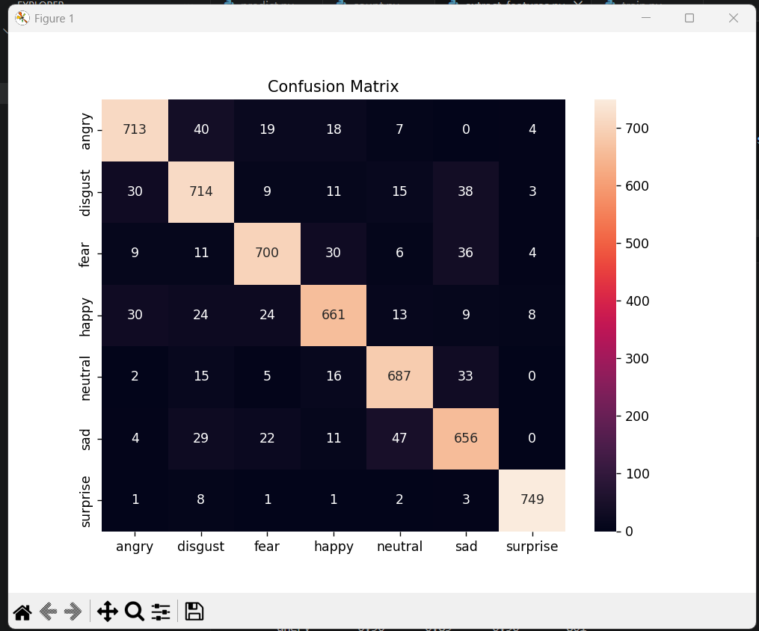
PS C:\Users\Chien\Desktop\SER> python count.py
========================================
THỐNG KÊ DATASET SER
========================================
angry : 2003 files (14.63%)
disgust : 2050 files (14.97%)
fear : 1990 files (14.53%)
happy : 1923 files (14.04%)
neutral : 1895 files (13.84%)
sad : 1923 files (14.04%)
surprise : 1911 files (13.95%)
========================================
TỔNG FILE: 13695
========================================
PS C:\Users\Chien\Desktop\SER> python extract_features.py
==================================================
SER FEATURE EXTRACTION
==================================================
Total wav files: 13695
Augment x2 enabled
==================================================

Processing emotion: angry
100/13695 (0.73%) | ETA: 55.7 min
200/13695 (1.46%) | ETA: 31.2 min
300/13695 (2.19%) | ETA: 23.0 min
400/13695 (2.92%) | ETA: 18.8 min
500/13695 (3.65%) | ETA: 16.2 min
600/13695 (4.38%) | ETA: 14.5 min
700/13695 (5.11%) | ETA: 13.2 min
800/13695 (5.84%) | ETA: 12.1 min
900/13695 (6.57%) | ETA: 11.3 min
1000/13695 (7.30%) | ETA: 10.6 min
1100/13695 (8.03%) | ETA: 10.0 min
1200/13695 (8.76%) | ETA: 9.6 min
1300/13695 (9.49%) | ETA: 9.2 min
1400/13695 (10.22%) | ETA: 8.8 min
1500/13695 (10.95%) | ETA: 8.5 min
1600/13695 (11.68%) | ETA: 8.2 min
1700/13695 (12.41%) | ETA: 8.0 min
1800/13695 (13.14%) | ETA: 7.8 min
1900/13695 (13.87%) | ETA: 7.6 min
2000/13695 (14.60%) | ETA: 7.4 min

Processing emotion: disgust
2100/13695 (15.33%) | ETA: 7.3 min
2200/13695 (16.06%) | ETA: 7.1 min
2300/13695 (16.79%) | ETA: 7.0 min
2400/13695 (17.52%) | ETA: 6.8 min
2500/13695 (18.25%) | ETA: 6.7 min
2600/13695 (18.99%) | ETA: 6.6 min
2700/13695 (19.72%) | ETA: 6.5 min
2800/13695 (20.45%) | ETA: 6.4 min
2900/13695 (21.18%) | ETA: 6.3 min
3000/13695 (21.91%) | ETA: 6.2 min
3100/13695 (22.64%) | ETA: 6.1 min
3200/13695 (23.37%) | ETA: 6.1 min
3300/13695 (24.10%) | ETA: 6.0 min
3400/13695 (24.83%) | ETA: 5.9 min
3500/13695 (25.56%) | ETA: 5.8 min
3600/13695 (26.29%) | ETA: 5.8 min
3700/13695 (27.02%) | ETA: 5.7 min
3800/13695 (27.75%) | ETA: 5.6 min
3900/13695 (28.48%) | ETA: 5.6 min
4000/13695 (29.21%) | ETA: 5.5 min

Processing emotion: fear
4100/13695 (29.94%) | ETA: 5.5 min
4200/13695 (30.67%) | ETA: 5.4 min
4300/13695 (31.40%) | ETA: 5.3 min
4400/13695 (32.13%) | ETA: 5.3 min
4500/13695 (32.86%) | ETA: 5.2 min
4600/13695 (33.59%) | ETA: 5.2 min
4700/13695 (34.32%) | ETA: 5.1 min
4800/13695 (35.05%) | ETA: 5.1 min
4900/13695 (35.78%) | ETA: 5.1 min
5000/13695 (36.51%) | ETA: 5.0 min
5100/13695 (37.24%) | ETA: 5.0 min
5200/13695 (37.97%) | ETA: 4.9 min
5300/13695 (38.70%) | ETA: 4.9 min
5400/13695 (39.43%) | ETA: 4.8 min
5500/13695 (40.16%) | ETA: 4.8 min
5600/13695 (40.89%) | ETA: 4.8 min
5700/13695 (41.62%) | ETA: 4.7 min
5800/13695 (42.35%) | ETA: 4.7 min
5900/13695 (43.08%) | ETA: 4.6 min
6000/13695 (43.81%) | ETA: 4.6 min

Processing emotion: happy
6100/13695 (44.54%) | ETA: 4.6 min
6200/13695 (45.27%) | ETA: 4.5 min
6300/13695 (46.00%) | ETA: 4.5 min
6400/13695 (46.73%) | ETA: 4.4 min
6500/13695 (47.46%) | ETA: 4.4 min
6600/13695 (48.19%) | ETA: 4.4 min
6700/13695 (48.92%) | ETA: 4.3 min
6800/13695 (49.65%) | ETA: 4.3 min
6900/13695 (50.38%) | ETA: 4.2 min
7000/13695 (51.11%) | ETA: 4.2 min
7100/13695 (51.84%) | ETA: 4.1 min
7200/13695 (52.57%) | ETA: 4.1 min
7300/13695 (53.30%) | ETA: 4.1 min
7400/13695 (54.03%) | ETA: 4.0 min
7500/13695 (54.76%) | ETA: 4.0 min
7600/13695 (55.49%) | ETA: 4.0 min
7700/13695 (56.22%) | ETA: 3.9 min
7800/13695 (56.96%) | ETA: 3.9 min
7900/13695 (57.69%) | ETA: 3.8 min

Processing emotion: neutral
8000/13695 (58.42%) | ETA: 3.8 min
8100/13695 (59.15%) | ETA: 3.8 min
8200/13695 (59.88%) | ETA: 3.7 min
8300/13695 (60.61%) | ETA: 3.7 min
8400/13695 (61.34%) | ETA: 3.7 min
8500/13695 (62.07%) | ETA: 3.6 min
8600/13695 (62.80%) | ETA: 3.6 min
8700/13695 (63.53%) | ETA: 3.5 min
8800/13695 (64.26%) | ETA: 3.5 min
8900/13695 (64.99%) | ETA: 3.5 min
9000/13695 (65.72%) | ETA: 3.4 min
9100/13695 (66.45%) | ETA: 3.4 min
9200/13695 (67.18%) | ETA: 3.3 min
9300/13695 (67.91%) | ETA: 3.3 min
9400/13695 (68.64%) | ETA: 3.2 min
9500/13695 (69.37%) | ETA: 3.2 min
9600/13695 (70.10%) | ETA: 3.1 min
9700/13695 (70.83%) | ETA: 3.0 min
9800/13695 (71.56%) | ETA: 3.0 min

Processing emotion: sad
9900/13695 (72.29%) | ETA: 2.9 min
10000/13695 (73.02%) | ETA: 2.9 min
10100/13695 (73.75%) | ETA: 2.8 min
10200/13695 (74.48%) | ETA: 2.7 min
10300/13695 (75.21%) | ETA: 2.7 min
10400/13695 (75.94%) | ETA: 2.6 min
10500/13695 (76.67%) | ETA: 2.6 min
10600/13695 (77.40%) | ETA: 2.5 min
10700/13695 (78.13%) | ETA: 2.4 min
10800/13695 (78.86%) | ETA: 2.4 min
10900/13695 (79.59%) | ETA: 2.3 min
11000/13695 (80.32%) | ETA: 2.2 min
11100/13695 (81.05%) | ETA: 2.2 min
11200/13695 (81.78%) | ETA: 2.1 min
11300/13695 (82.51%) | ETA: 2.0 min
11400/13695 (83.24%) | ETA: 1.9 min
11500/13695 (83.97%) | ETA: 1.9 min
11600/13695 (84.70%) | ETA: 1.8 min
11700/13695 (85.43%) | ETA: 1.7 min

Processing emotion: surprise
11800/13695 (86.16%) | ETA: 1.6 min
11900/13695 (86.89%) | ETA: 1.6 min
12000/13695 (87.62%) | ETA: 1.5 min
12100/13695 (88.35%) | ETA: 1.4 min
12200/13695 (89.08%) | ETA: 1.3 min
12300/13695 (89.81%) | ETA: 1.3 min
12400/13695 (90.54%) | ETA: 1.2 min
12500/13695 (91.27%) | ETA: 1.1 min
12600/13695 (92.00%) | ETA: 1.0 min
12700/13695 (92.73%) | ETA: 0.9 min
12800/13695 (93.46%) | ETA: 0.8 min
12900/13695 (94.19%) | ETA: 0.7 min
13000/13695 (94.93%) | ETA: 0.6 min
13100/13695 (95.66%) | ETA: 0.6 min
13200/13695 (96.39%) | ETA: 0.5 min
13300/13695 (97.12%) | ETA: 0.4 min
13400/13695 (97.85%) | ETA: 0.3 min
13500/13695 (98.58%) | ETA: 0.2 min
13600/13695 (99.31%) | ETA: 0.1 min

==================================================
Saving numpy files...
X shape: (27390, 130, 128)
y shape: (27390,)
Saved X.npy and y.npy
==================================================
PS C:\Users\Chien\Desktop\SER> python train.py
2026-05-17 06:52:23.930049: I tensorflow/core/util/port.cc:153] oneDNN custom operations are on. You may see slightly different numerical results due to floating-point round-off errors from different computation orders. To turn them off, set the environment variable `TF_ENABLE_ONEDNN_OPTS=0`.
2026-05-17 06:52:30.429063: I tensorflow/core/util/port.cc:153] oneDNN custom operations are on. You may see slightly different numerical results due to floating-point round-off errors from different computation orders. To turn them off, set the environment variable `TF_ENABLE_ONEDNN_OPTS=0`.
Data: (27390, 130, 128)
Labels: ['angry' 'disgust' 'fear' 'happy' 'neutral' 'sad' 'surprise']
2026-05-17 06:52:36.733309: I tensorflow/core/platform/cpu_feature_guard.cc:210] This TensorFlow binary is optimized to use available CPU instructions in performance-critical operations.
To enable the following instructions: SSE3 SSE4.1 SSE4.2 AVX AVX2 AVX_VNNI FMA, in other operations, rebuild TensorFlow with the appropriate compiler flags.
WARNING:tensorflow:From C:\Users\Chien\AppData\Local\Programs\Python\Python310\lib\site-packages\keras\src\backend\tensorflow\core.py:232: The name tf.placeholder is deprecated. Please use tf.compat.v1.placeholder instead.

Epoch 1/40
2026-05-17 06:52:41.103423: E tensorflow/core/util/util.cc:131] oneDNN supports DT_INT32 only on platforms with AVX-512. Falling back to the default Eigen-based implementation if present.
685/685 ━━━━━━━━━━━━━━━━━━━━ 223s 321ms/step - accuracy: 0.4345 - loss: 1.5773 - val_accuracy: 0.5646 - val_loss: 1.3402 - learning_rate: 1.0000e-04
Epoch 2/40
685/685 ━━━━━━━━━━━━━━━━━━━━ 265s 326ms/step - accuracy: 0.5851 - loss: 1.3026 - val_accuracy: 0.6446 - val_loss: 1.1941 - learning_rate: 1.0000e-04
Epoch 3/40
685/685 ━━━━━━━━━━━━━━━━━━━━ 230s 335ms/step - accuracy: 0.6433 - loss: 1.2011 - val_accuracy: 0.6659 - val_loss: 1.1390 - learning_rate: 1.0000e-04
Epoch 4/40
685/685 ━━━━━━━━━━━━━━━━━━━━ 231s 337ms/step - accuracy: 0.6763 - loss: 1.1387 - val_accuracy: 0.6756 - val_loss: 1.1222 - learning_rate: 1.0000e-04
Epoch 5/40
685/685 ━━━━━━━━━━━━━━━━━━━━ 231s 337ms/step - accuracy: 0.7041 - loss: 1.0853 - val_accuracy: 0.6995 - val_loss: 1.0601 - learning_rate: 1.0000e-04
Epoch 6/40
685/685 ━━━━━━━━━━━━━━━━━━━━ 231s 337ms/step - accuracy: 0.7267 - loss: 1.0414 - val_accuracy: 0.7083 - val_loss: 1.0529 - learning_rate: 1.0000e-04
Epoch 7/40
685/685 ━━━━━━━━━━━━━━━━━━━━ 230s 336ms/step - accuracy: 0.7526 - loss: 0.9995 - val_accuracy: 0.7171 - val_loss: 1.0279 - learning_rate: 1.0000e-04
Epoch 8/40
685/685 ━━━━━━━━━━━━━━━━━━━━ 231s 338ms/step - accuracy: 0.7680 - loss: 0.9623 - val_accuracy: 0.6866 - val_loss: 1.0930 - learning_rate: 1.0000e-04
Epoch 9/40
685/685 ━━━━━━━━━━━━━━━━━━━━ 231s 337ms/step - accuracy: 0.7971 - loss: 0.9159 - val_accuracy: 0.7326 - val_loss: 1.0150 - learning_rate: 1.0000e-04
Epoch 10/40
685/685 ━━━━━━━━━━━━━━━━━━━━ 230s 335ms/step - accuracy: 0.8123 - loss: 0.8817 - val_accuracy: 0.7536 - val_loss: 0.9675 - learning_rate: 1.0000e-04
Epoch 11/40
685/685 ━━━━━━━━━━━━━━━━━━━━ 231s 337ms/step - accuracy: 0.8292 - loss: 0.8537 - val_accuracy: 0.7693 - val_loss: 0.9438 - learning_rate: 1.0000e-04
Epoch 12/40
685/685 ━━━━━━━━━━━━━━━━━━━━ 230s 336ms/step - accuracy: 0.8498 - loss: 0.8130 - val_accuracy: 0.7742 - val_loss: 0.9565 - learning_rate: 1.0000e-04
Epoch 13/40
685/685 ━━━━━━━━━━━━━━━━━━━━ 231s 338ms/step - accuracy: 0.8686 - loss: 0.7806 - val_accuracy: 0.7822 - val_loss: 0.9287 - learning_rate: 1.0000e-04
Epoch 14/40
685/685 ━━━━━━━━━━━━━━━━━━━━ 232s 339ms/step - accuracy: 0.8815 - loss: 0.7518 - val_accuracy: 0.7954 - val_loss: 0.9152 - learning_rate: 1.0000e-04
Epoch 15/40
685/685 ━━━━━━━━━━━━━━━━━━━━ 232s 339ms/step - accuracy: 0.8959 - loss: 0.7239 - val_accuracy: 0.7691 - val_loss: 0.9714 - learning_rate: 1.0000e-04
Epoch 16/40
685/685 ━━━━━━━━━━━━━━━━━━━━ 232s 338ms/step - accuracy: 0.9064 - loss: 0.7028 - val_accuracy: 0.8118 - val_loss: 0.8755 - learning_rate: 1.0000e-04
Epoch 17/40
685/685 ━━━━━━━━━━━━━━━━━━━━ 233s 340ms/step - accuracy: 0.9151 - loss: 0.6879 - val_accuracy: 0.8018 - val_loss: 0.8938 - learning_rate: 1.0000e-04
Epoch 18/40
685/685 ━━━━━━━━━━━━━━━━━━━━ 233s 341ms/step - accuracy: 0.9240 - loss: 0.6678 - val_accuracy: 0.7505 - val_loss: 1.0337 - learning_rate: 1.0000e-04
Epoch 19/40
685/685 ━━━━━━━━━━━━━━━━━━━━ 234s 342ms/step - accuracy: 0.9569 - loss: 0.6047 - val_accuracy: 0.8673 - val_loss: 0.7817 - learning_rate: 1.0000e-05
Epoch 20/40
685/685 ━━━━━━━━━━━━━━━━━━━━ 234s 342ms/step - accuracy: 0.9651 - loss: 0.5869 - val_accuracy: 0.8697 - val_loss: 0.7742 - learning_rate: 1.0000e-05
Epoch 21/40
685/685 ━━━━━━━━━━━━━━━━━━━━ 235s 342ms/step - accuracy: 0.9702 - loss: 0.5793 - val_accuracy: 0.8755 - val_loss: 0.7658 - learning_rate: 1.0000e-05
Epoch 22/40
685/685 ━━━━━━━━━━━━━━━━━━━━ 239s 349ms/step - accuracy: 0.9719 - loss: 0.5755 - val_accuracy: 0.8744 - val_loss: 0.7656 - learning_rate: 1.0000e-05
Epoch 23/40
685/685 ━━━━━━━━━━━━━━━━━━━━ 233s 341ms/step - accuracy: 0.9732 - loss: 0.5694 - val_accuracy: 0.8742 - val_loss: 0.7620 - learning_rate: 1.0000e-05
Epoch 24/40
685/685 ━━━━━━━━━━━━━━━━━━━━ 237s 346ms/step - accuracy: 0.9746 - loss: 0.5651 - val_accuracy: 0.8722 - val_loss: 0.7680 - learning_rate: 1.0000e-05
Epoch 25/40
685/685 ━━━━━━━━━━━━━━━━━━━━ 236s 345ms/step - accuracy: 0.9780 - loss: 0.5599 - val_accuracy: 0.8826 - val_loss: 0.7515 - learning_rate: 1.0000e-05
Epoch 26/40
685/685 ━━━━━━━━━━━━━━━━━━━━ 236s 345ms/step - accuracy: 0.9761 - loss: 0.5609 - val_accuracy: 0.8844 - val_loss: 0.7496 - learning_rate: 1.0000e-05
Epoch 27/40
685/685 ━━━━━━━━━━━━━━━━━━━━ 236s 345ms/step - accuracy: 0.9790 - loss: 0.5558 - val_accuracy: 0.8834 - val_loss: 0.7466 - learning_rate: 1.0000e-05
Epoch 28/40
685/685 ━━━━━━━━━━━━━━━━━━━━ 236s 345ms/step - accuracy: 0.9796 - loss: 0.5521 - val_accuracy: 0.8890 - val_loss: 0.7419 - learning_rate: 1.0000e-05
Epoch 29/40
685/685 ━━━━━━━━━━━━━━━━━━━━ 236s 345ms/step - accuracy: 0.9814 - loss: 0.5478 - val_accuracy: 0.8865 - val_loss: 0.7431 - learning_rate: 1.0000e-05
Epoch 30/40
685/685 ━━━━━━━━━━━━━━━━━━━━ 236s 344ms/step - accuracy: 0.9820 - loss: 0.5475 - val_accuracy: 0.8877 - val_loss: 0.7448 - learning_rate: 1.0000e-05
Epoch 31/40
685/685 ━━━━━━━━━━━━━━━━━━━━ 237s 346ms/step - accuracy: 0.9839 - loss: 0.5422 - val_accuracy: 0.8905 - val_loss: 0.7367 - learning_rate: 1.0000e-06
Epoch 32/40
685/685 ━━━━━━━━━━━━━━━━━━━━ 237s 346ms/step - accuracy: 0.9849 - loss: 0.5402 - val_accuracy: 0.8907 - val_loss: 0.7366 - learning_rate: 1.0000e-06
Epoch 33/40
685/685 ━━━━━━━━━━━━━━━━━━━━ 236s 345ms/step - accuracy: 0.9859 - loss: 0.5394 - val_accuracy: 0.8910 - val_loss: 0.7346 - learning_rate: 1.0000e-06
Epoch 34/40
685/685 ━━━━━━━━━━━━━━━━━━━━ 238s 347ms/step - accuracy: 0.9848 - loss: 0.5407 - val_accuracy: 0.8901 - val_loss: 0.7353 - learning_rate: 1.0000e-06
Epoch 35/40
685/685 ━━━━━━━━━━━━━━━━━━━━ 237s 346ms/step - accuracy: 0.9856 - loss: 0.5401 - val_accuracy: 0.8914 - val_loss: 0.7346 - learning_rate: 1.0000e-06
Epoch 36/40
685/685 ━━━━━━━━━━━━━━━━━━━━ 237s 346ms/step - accuracy: 0.9858 - loss: 0.5388 - val_accuracy: 0.8910 - val_loss: 0.7343 - learning_rate: 1.0000e-07
Epoch 37/40
685/685 ━━━━━━━━━━━━━━━━━━━━ 237s 346ms/step - accuracy: 0.9859 - loss: 0.5377 - val_accuracy: 0.8910 - val_loss: 0.7346 - learning_rate: 1.0000e-07
Epoch 38/40
685/685 ━━━━━━━━━━━━━━━━━━━━ 238s 347ms/step - accuracy: 0.9864 - loss: 0.5380 - val_accuracy: 0.8916 - val_loss: 0.7345 - learning_rate: 1.0000e-07
Epoch 39/40
685/685 ━━━━━━━━━━━━━━━━━━━━ 237s 346ms/step - accuracy: 0.9854 - loss: 0.5399 - val_accuracy: 0.8908 - val_loss: 0.7343 - learning_rate: 1.0000e-08
Epoch 40/40
685/685 ━━━━━━━━━━━━━━━━━━━━ 237s 346ms/step - accuracy: 0.9860 - loss: 0.5380 - val_accuracy: 0.8907 - val_loss: 0.7344 - learning_rate: 1.0000e-08
172/172 ━━━━━━━━━━━━━━━━━━━━ 14s 83ms/step

FINAL REPORT
precision recall f1-score support

angry 0.90 0.89 0.90 801
disgust 0.85 0.87 0.86 820
fear 0.90 0.88 0.89 796
happy 0.88 0.86 0.87 769
neutral 0.88 0.91 0.90 758
sad 0.85 0.85 0.85 769
surprise 0.98 0.98 0.98 765

accuracy 0.89 5478
macro avg 0.89 0.89 0.89 5478
weighted avg 0.89 0.89 0.89 5478

DONE

Tổng quan kết quả
Accuracy: 89%
Macro F1-score: $0.89$
=> model không chỉ đoán đúng tổng thể mà còn cân bằng giữa các class.
Đánh giá training
1. Learning ổn định
Accuracy tăng đều: 0.43 → 0.98 train accuracy
Validation accuracy: 0.56 → 0.89
=> model học tốt, không bị đứng.
2. Validation loss giảm đẹp
Val loss: 1.34 → 0.73
=> model generalize khá tốt.
Có overfitting nhẹ.
Train accuracy ≈ 98%
Val accuracy ≈ 89%
Chênh khoảng 9%.
Phân tích từng emotion
Surprise
F1 = 0.98
Rất mạnh.
Angry / Fear / Neutral
0.89 - 0.90
Rất tốt.
Happy / Sad / Disgust
0.85 - 0.87

Model cnn2d+Bilstm

Kết quả sau train
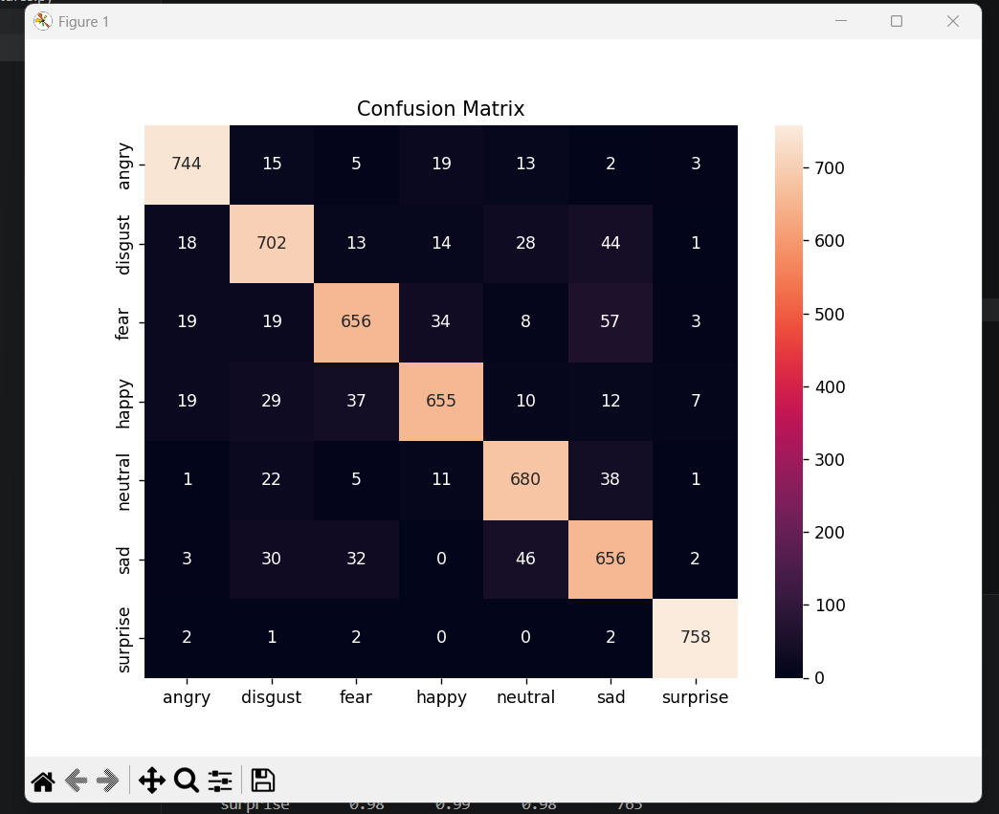

PS C:\Users\Chien\Desktop\SER> python train.py
2026-05-17 09:58:50.385230: I tensorflow/core/util/port.cc:153] oneDNN custom operations are on. You may see slightly different numerical results due to floating-point round-off errors from different computation orders. To turn them off, set the environment variable `TF_ENABLE_ONEDNN_OPTS=0`.
2026-05-17 09:59:02.842578: I tensorflow/core/util/port.cc:153] oneDNN custom operations are on. You may see slightly different numerical results due to floating-point round-off errors from different computation orders. To turn them off, set the environment variable `TF_ENABLE_ONEDNN_OPTS=0`.
Data: (27390, 130, 128)
Labels: ['angry' 'disgust' 'fear' 'happy' 'neutral' 'sad' 'surprise']
2026-05-17 09:59:18.439360: I tensorflow/core/platform/cpu_feature_guard.cc:210] This TensorFlow binary is optimized to use available CPU instructions in performance-critical operations.
To enable the following instructions: SSE3 SSE4.1 SSE4.2 AVX AVX2 AVX_VNNI FMA, in other operations, rebuild TensorFlow with the appropriate compiler flags.
Epoch 1/40
685/685 ━━━━━━━━━━━━━━━━━━━━ 251s 363ms/step - accuracy: 0.3921 - loss: 1.6395 - val_accuracy: 0.5097 - val_loss: 1.4299 - learning_rate: 1.0000e-04
Epoch 2/40
685/685 ━━━━━━━━━━━━━━━━━━━━ 255s 372ms/step - accuracy: 0.5223 - loss: 1.4185 - val_accuracy: 0.5577 - val_loss: 1.3378 - learning_rate: 1.0000e-04
Epoch 3/40
685/685 ━━━━━━━━━━━━━━━━━━━━ 257s 375ms/step - accuracy: 0.5744 - loss: 1.3202 - val_accuracy: 0.5878 - val_loss: 1.2747 - learning_rate: 1.0000e-04
Epoch 4/40
685/685 ━━━━━━━━━━━━━━━━━━━━ 257s 375ms/step - accuracy: 0.6051 - loss: 1.2529 - val_accuracy: 0.6208 - val_loss: 1.2300 - learning_rate: 1.0000e-04
Epoch 5/40
685/685 ━━━━━━━━━━━━━━━━━━━━ 259s 378ms/step - accuracy: 0.6452 - loss: 1.1954 - val_accuracy: 0.6166 - val_loss: 1.2045 - learning_rate: 1.0000e-04
Epoch 6/40
685/685 ━━━━━━━━━━━━━━━━━━━━ 259s 378ms/step - accuracy: 0.6697 - loss: 1.1477 - val_accuracy: 0.6442 - val_loss: 1.1853 - learning_rate: 1.0000e-04
Epoch 7/40
685/685 ━━━━━━━━━━━━━━━━━━━━ 259s 378ms/step - accuracy: 0.6911 - loss: 1.1069 - val_accuracy: 0.6679 - val_loss: 1.1218 - learning_rate: 1.0000e-04
Epoch 8/40
685/685 ━━━━━━━━━━━━━━━━━━━━ 260s 379ms/step - accuracy: 0.7140 - loss: 1.0650 - val_accuracy: 0.6592 - val_loss: 1.1307 - learning_rate: 1.0000e-04
Epoch 9/40
685/685 ━━━━━━━━━━━━━━━━━━━━ 261s 381ms/step - accuracy: 0.7333 - loss: 1.0291 - val_accuracy: 0.7052 - val_loss: 1.0670 - learning_rate: 1.0000e-04
Epoch 10/40
685/685 ━━━━━━━━━━━━━━━━━━━━ 270s 394ms/step - accuracy: 0.7545 - loss: 0.9913 - val_accuracy: 0.7240 - val_loss: 1.0230 - learning_rate: 1.0000e-04
Epoch 11/40
685/685 ━━━━━━━━━━━━━━━━━━━━ 273s 398ms/step - accuracy: 0.7709 - loss: 0.9597 - val_accuracy: 0.7379 - val_loss: 1.0006 - learning_rate: 1.0000e-04
Epoch 12/40
685/685 ━━━━━━━━━━━━━━━━━━━━ 273s 399ms/step - accuracy: 0.7983 - loss: 0.9154 - val_accuracy: 0.7222 - val_loss: 1.0398 - learning_rate: 1.0000e-04
Epoch 13/40
685/685 ━━━━━━━━━━━━━━━━━━━━ 272s 397ms/step - accuracy: 0.8134 - loss: 0.8796 - val_accuracy: 0.7537 - val_loss: 0.9775 - learning_rate: 1.0000e-04
Epoch 14/40
685/685 ━━━━━━━━━━━━━━━━━━━━ 262s 382ms/step - accuracy: 0.8375 - loss: 0.8449 - val_accuracy: 0.7678 - val_loss: 0.9535 - learning_rate: 1.0000e-04
Epoch 15/40
685/685 ━━━━━━━━━━━━━━━━━━━━ 261s 382ms/step - accuracy: 0.8531 - loss: 0.8140 - val_accuracy: 0.7802 - val_loss: 0.9308 - learning_rate: 1.0000e-04
Epoch 16/40
685/685 ━━━━━━━━━━━━━━━━━━━━ 262s 382ms/step - accuracy: 0.8738 - loss: 0.7786 - val_accuracy: 0.7950 - val_loss: 0.9014 - learning_rate: 1.0000e-04
Epoch 17/40
685/685 ━━━━━━━━━━━━━━━━━━━━ 261s 381ms/step - accuracy: 0.8890 - loss: 0.7511 - val_accuracy: 0.8032 - val_loss: 0.8895 - learning_rate: 1.0000e-04
Epoch 18/40
685/685 ━━━━━━━━━━━━━━━━━━━━ 261s 381ms/step - accuracy: 0.9007 - loss: 0.7264 - val_accuracy: 0.7948 - val_loss: 0.9145 - learning_rate: 1.0000e-04
Epoch 19/40
685/685 ━━━━━━━━━━━━━━━━━━━━ 263s 383ms/step - accuracy: 0.9176 - loss: 0.6989 - val_accuracy: 0.7742 - val_loss: 0.9540 - learning_rate: 1.0000e-04
Epoch 20/40
685/685 ━━━━━━━━━━━━━━━━━━━━ 264s 385ms/step - accuracy: 0.9505 - loss: 0.6368 - val_accuracy: 0.8591 - val_loss: 0.7996 - learning_rate: 1.0000e-05
Epoch 21/40
685/685 ━━━━━━━━━━━━━━━━━━━━ 263s 384ms/step - accuracy: 0.9567 - loss: 0.6239 - val_accuracy: 0.8635 - val_loss: 0.7938 - learning_rate: 1.0000e-05
Epoch 22/40
685/685 ━━━━━━━━━━━━━━━━━━━━ 263s 384ms/step - accuracy: 0.9607 - loss: 0.6186 - val_accuracy: 0.8635 - val_loss: 0.7930 - learning_rate: 1.0000e-05
Epoch 23/40
685/685 ━━━━━━━━━━━━━━━━━━━━ 263s 385ms/step - accuracy: 0.9613 - loss: 0.6155 - val_accuracy: 0.8667 - val_loss: 0.7867 - learning_rate: 1.0000e-05
Epoch 24/40
685/685 ━━━━━━━━━━━━━━━━━━━━ 262s 382ms/step - accuracy: 0.9638 - loss: 0.6117 - val_accuracy: 0.8697 - val_loss: 0.7827 - learning_rate: 1.0000e-05
Epoch 25/40
685/685 ━━━━━━━━━━━━━━━━━━━━ 264s 385ms/step - accuracy: 0.9650 - loss: 0.6075 - val_accuracy: 0.8760 - val_loss: 0.7767 - learning_rate: 1.0000e-05
Epoch 26/40
685/685 ━━━━━━━━━━━━━━━━━━━━ 263s 384ms/step - accuracy: 0.9670 - loss: 0.6047 - val_accuracy: 0.8750 - val_loss: 0.7768 - learning_rate: 1.0000e-05
Epoch 27/40
685/685 ━━━━━━━━━━━━━━━━━━━━ 263s 384ms/step - accuracy: 0.9698 - loss: 0.6011 - val_accuracy: 0.8801 - val_loss: 0.7704 - learning_rate: 1.0000e-05
Epoch 28/40
685/685 ━━━━━━━━━━━━━━━━━━━━ 268s 391ms/step - accuracy: 0.9697 - loss: 0.5999 - val_accuracy: 0.8786 - val_loss: 0.7677 - learning_rate: 1.0000e-05
Epoch 29/40
685/685 ━━━━━━━━━━━━━━━━━━━━ 264s 385ms/step - accuracy: 0.9712 - loss: 0.5964 - val_accuracy: 0.8792 - val_loss: 0.7719 - learning_rate: 1.0000e-05
Epoch 30/40
685/685 ━━━━━━━━━━━━━━━━━━━━ 271s 395ms/step - accuracy: 0.9717 - loss: 0.5920 - val_accuracy: 0.8771 - val_loss: 0.7699 - learning_rate: 1.0000e-05
Epoch 31/40
685/685 ━━━━━━━━━━━━━━━━━━━━ 268s 392ms/step - accuracy: 0.9754 - loss: 0.5865 - val_accuracy: 0.8843 - val_loss: 0.7611 - learning_rate: 1.0000e-06
Epoch 32/40
685/685 ━━━━━━━━━━━━━━━━━━━━ 268s 392ms/step - accuracy: 0.9762 - loss: 0.5875 - val_accuracy: 0.8865 - val_loss: 0.7600 - learning_rate: 1.0000e-06
Epoch 33/40
685/685 ━━━━━━━━━━━━━━━━━━━━ 267s 390ms/step - accuracy: 0.9764 - loss: 0.5855 - val_accuracy: 0.8863 - val_loss: 0.7599 - learning_rate: 1.0000e-06
Epoch 34/40
685/685 ━━━━━━━━━━━━━━━━━━━━ 268s 392ms/step - accuracy: 0.9748 - loss: 0.5854 - val_accuracy: 0.8857 - val_loss: 0.7596 - learning_rate: 1.0000e-06
Epoch 35/40
685/685 ━━━━━━━━━━━━━━━━━━━━ 269s 392ms/step - accuracy: 0.9760 - loss: 0.5846 - val_accuracy: 0.8843 - val_loss: 0.7595 - learning_rate: 1.0000e-06
Epoch 36/40
685/685 ━━━━━━━━━━━━━━━━━━━━ 267s 390ms/step - accuracy: 0.9763 - loss: 0.5842 - val_accuracy: 0.8854 - val_loss: 0.7587 - learning_rate: 1.0000e-06
Epoch 37/40
685/685 ━━━━━━━━━━━━━━━━━━━━ 265s 388ms/step - accuracy: 0.9772 - loss: 0.5842 - val_accuracy: 0.8852 - val_loss: 0.7588 - learning_rate: 1.0000e-06
Epoch 38/40
685/685 ━━━━━━━━━━━━━━━━━━━━ 267s 390ms/step - accuracy: 0.9767 - loss: 0.5838 - val_accuracy: 0.8855 - val_loss: 0.7580 - learning_rate: 1.0000e-06
Epoch 39/40
685/685 ━━━━━━━━━━━━━━━━━━━━ 267s 390ms/step - accuracy: 0.9777 - loss: 0.5827 - val_accuracy: 0.8848 - val_loss: 0.7584 - learning_rate: 1.0000e-06
Epoch 40/40
685/685 ━━━━━━━━━━━━━━━━━━━━ 268s 391ms/step - accuracy: 0.9784 - loss: 0.5833 - val_accuracy: 0.8854 - val_loss: 0.7587 - learning_rate: 1.0000e-06
172/172 ━━━━━━━━━━━━━━━━━━━━ 16s 91ms/step

FINAL REPORT
precision recall f1-score support

angry 0.92 0.93 0.93 801
disgust 0.86 0.86 0.86 820
fear 0.87 0.82 0.85 796
happy 0.89 0.85 0.87 769
neutral 0.87 0.90 0.88 758
sad 0.81 0.85 0.83 769
surprise 0.98 0.99 0.98 765

accuracy 0.89 5478
macro avg 0.89 0.89 0.89 5478
weighted avg 0.89 0.89 0.89 5478

DONE

Tổng quan kết quả
- Accuracy: 0.89 (89%)
- Macro F1: 0.89
- Weighted F1: 0.89
=> Model đang ổn và học khá tốt, không bị lệch class quá nặng.
Phân tích chi tiết
Các class mạnh nhất
Emotion | F1-score
surprise | 0.98
angry | 0.93
neutral | 0.88
Happy | 0.87
sad | 0.83

fear | 0.85

disgust | 0.86

learning curve
Model học rất đẹp:
Giai đoạn đầu
acc: 0.39 -> 0.70
=> CNN đang học feature âm thanh tốt.
Giai đoạn giữa
val_acc ~ 0.80
=> BiLSTM bắt đầu học temporal pattern.
Giai đoạn cuối
val_acc ~ 0.885
=> model gần hội tụ.
Overfitting nhẹ.
train acc = 97%
val acc = 88%

so sánh 2 model

run 1: Model cnn2d+Bilstm

run 2: Model cnn2d+Bilstm+attention
So sánh tổng quát
Metric | Run 1 | Run 2
Validation Accuracy tốt nhất | ~88.65% | ~89.16%
Final Accuracy | 88.54% | 89.07%
Macro F1 | 0.89 | 0.89
Weighted F1 | 0.89 | 0.89
Overfitting | Có nhẹ | Ít hơn
Training speed | ~390ms/step | ~345ms/step

Nhận xét chi tiết
1. Accuracy
Run 1:
- Final val_accuracy ≈ 88.54%
Run 2:
- Final val_accuracy ≈ 89.07%
=> Run 2 tăng khoảng:
$$89.07\%-88.54\%≈0.53\%$$
2. So sánh từng emotion
Emotion | Run 1 F1 | Run 2 F1 | Tốt hơn
angry | 0.93 | 0.90 | Run 1
disgust | 0.86 | 0.86 | Bằng
fear | 0.85 | 0.89 | Run 2 mạnh
happy | 0.87 | 0.87 | Bằng
neutral | 0.88 | 0.90 | Run 2
sad | 0.83 | 0.85 | Run 2
surprise | 0.98 | 0.98 | Bằng
Run 2 cải thiện rõ:
- fear
- neutral
- sad
3. Overfitting
Run 1
Train accuracy cuối:
- ~97.8%
Validation:
- ~88.5%
Gap:
$$97.8\%-88.5\%≈9.3\%$$
Run 2
Train:
- ~98.6%
Validation:
- ~89.1%
Gap:
$$98.6\%-89.1\%≈9.5\%$$
4. Learning curve
Run 1
Có vài epoch validation tụt:
- epoch 18 tụt mạnh còn 77%
=> model hơi dao động.
Run 2
Validation tăng mượt hơn:
- 86 → 87 → 88 → 89
Loss giảm đều hơn:
- tốt hơn về optimization.
5. Kết luận cuối
Run tốt hơn: Run 2 (Model cnn2d+Bilstm+attention)
Vì:
- Accuracy cao hơn
- Validation ổn định hơn
- Fear/sad/neutral cải thiện
- Dataset augmentation tốt hơn
- Generalization tốt hơn

